The free GPU

1. Kaggle kernel (free 30h per week)

The website: <https://www.kaggle.com/>

1. Sign in or register

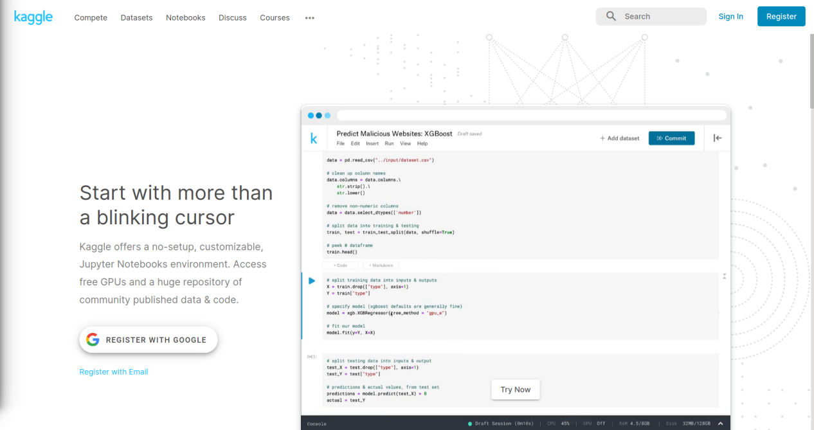

1. Click the Competitions and join any competition group, such as: Titanic: Machine learning from Disaster

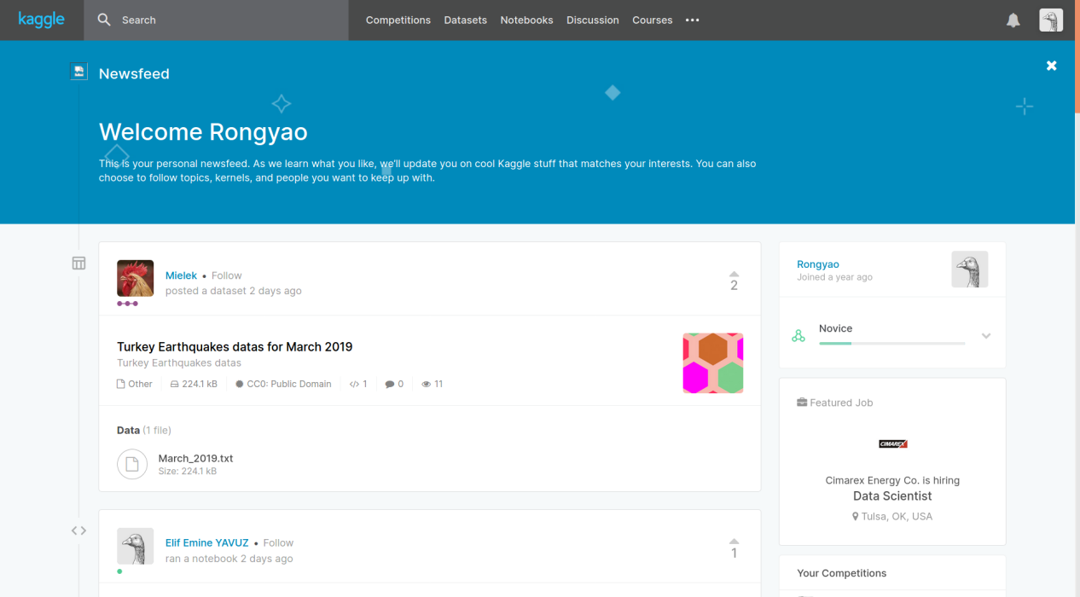

1. Choose Notebooks and click New Notebook

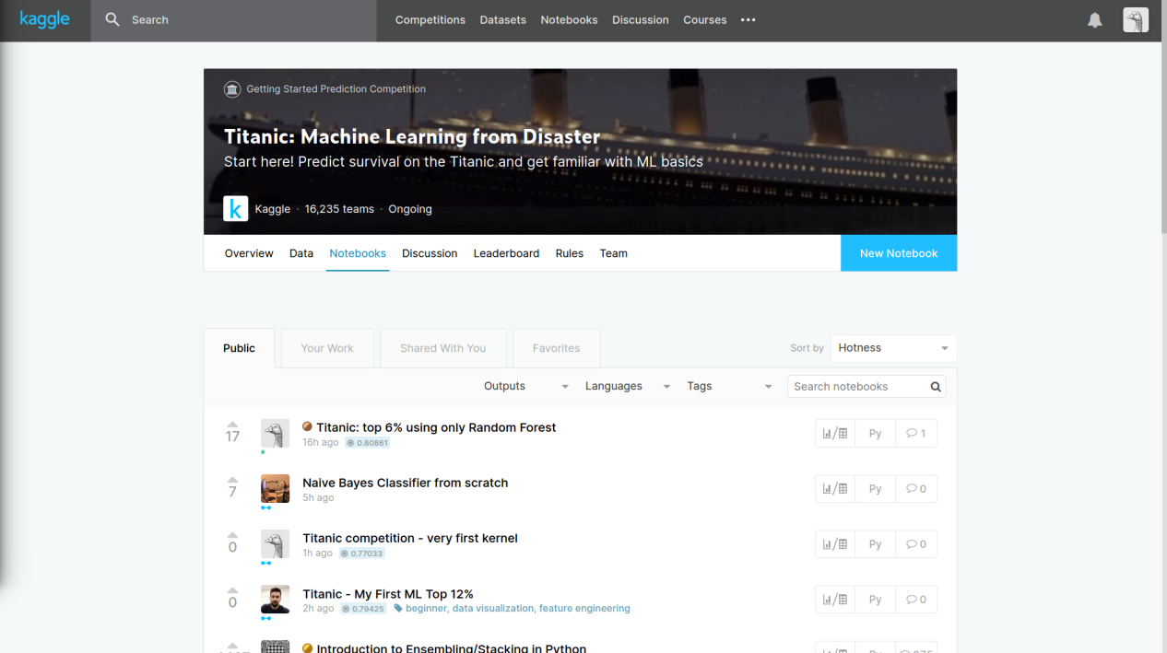

1. Select language and select type, and click Create

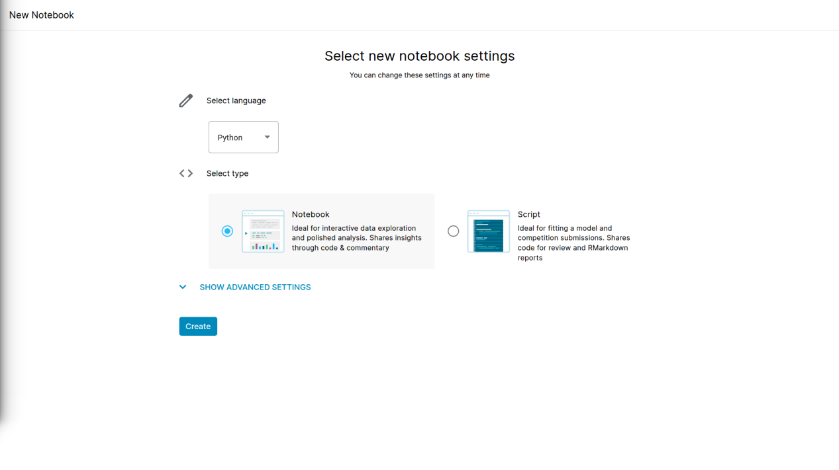

1. Add data by yourself and select the Accelerator (GPU or TPU v3-8) after you confirm with your mobile number

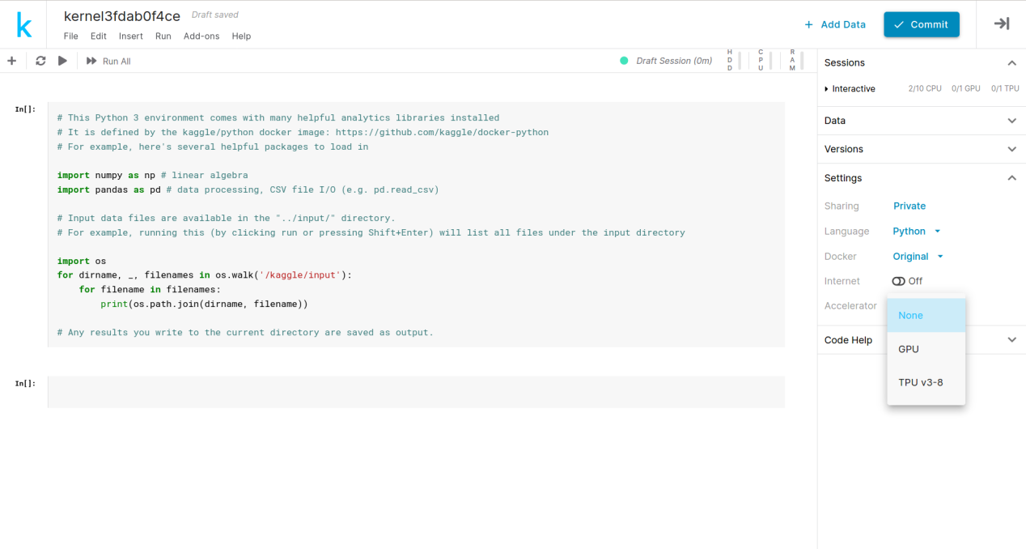

1. Click Commit and wait for upload

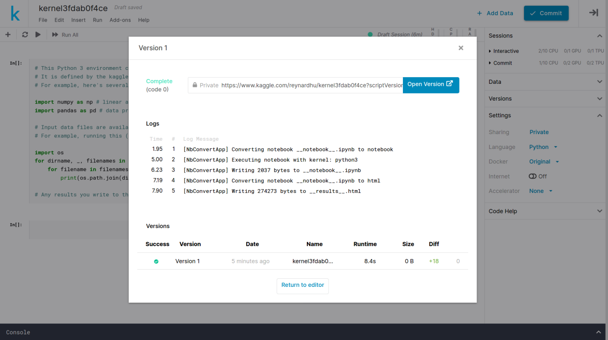

1. Download code to the local

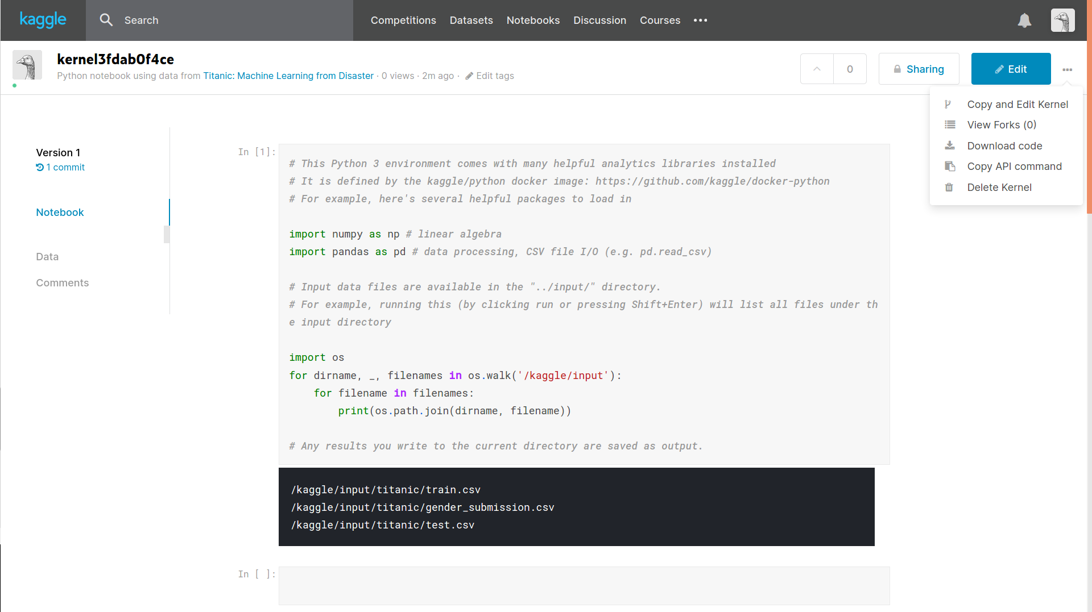

1. Colab

The website: http://drive.google.com

1. Entry the Drive in your google account , and select New/More/Google Colaboratory

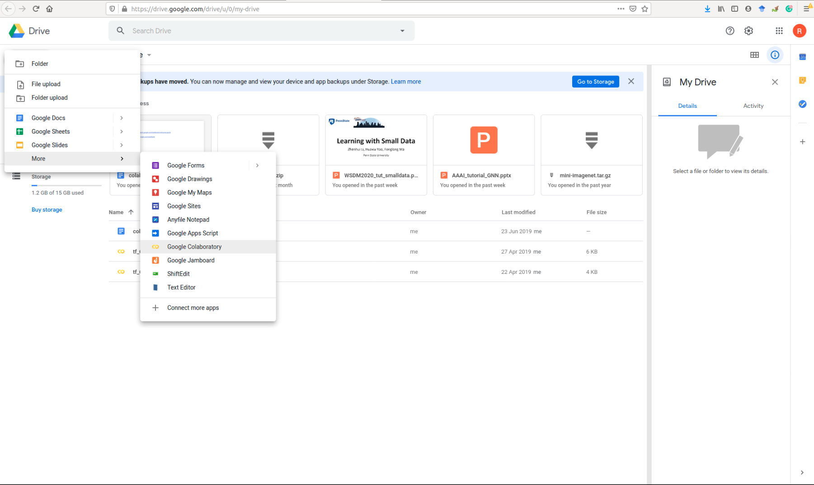

1. If you cannot find Google Colaboratory, click + Connect More apps, search Colaboratory and install

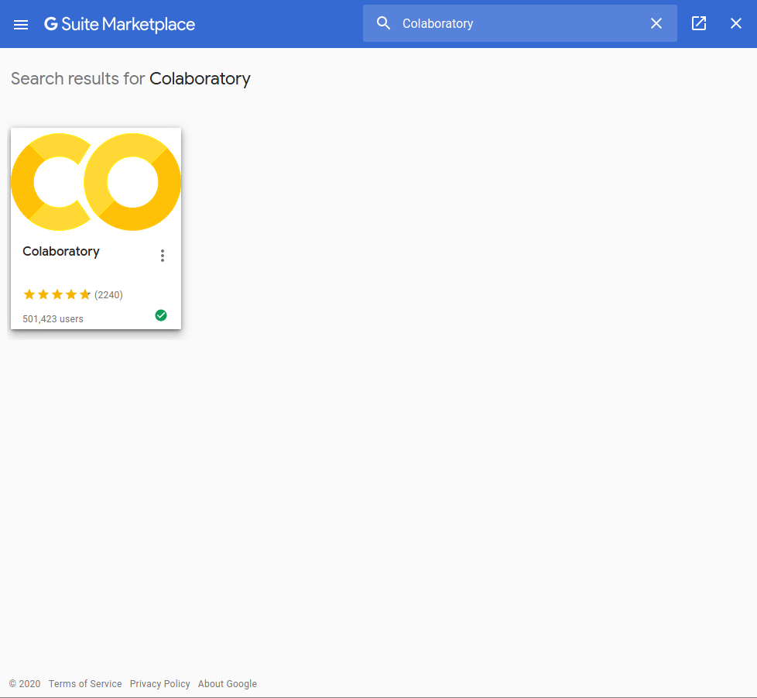

1. Start your code and click Edit/Notebook setting

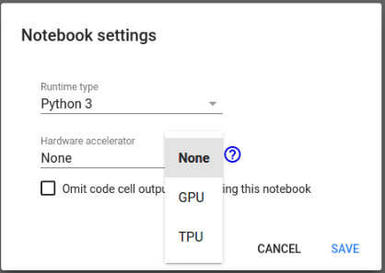

1. Add data by yourself

4.1) download from github

4.1.1)

!git clone https://github.com/JameyWoo/myDataSet.git

!pwd

!ls -R

(View files in the current directory and all subdirectory files)

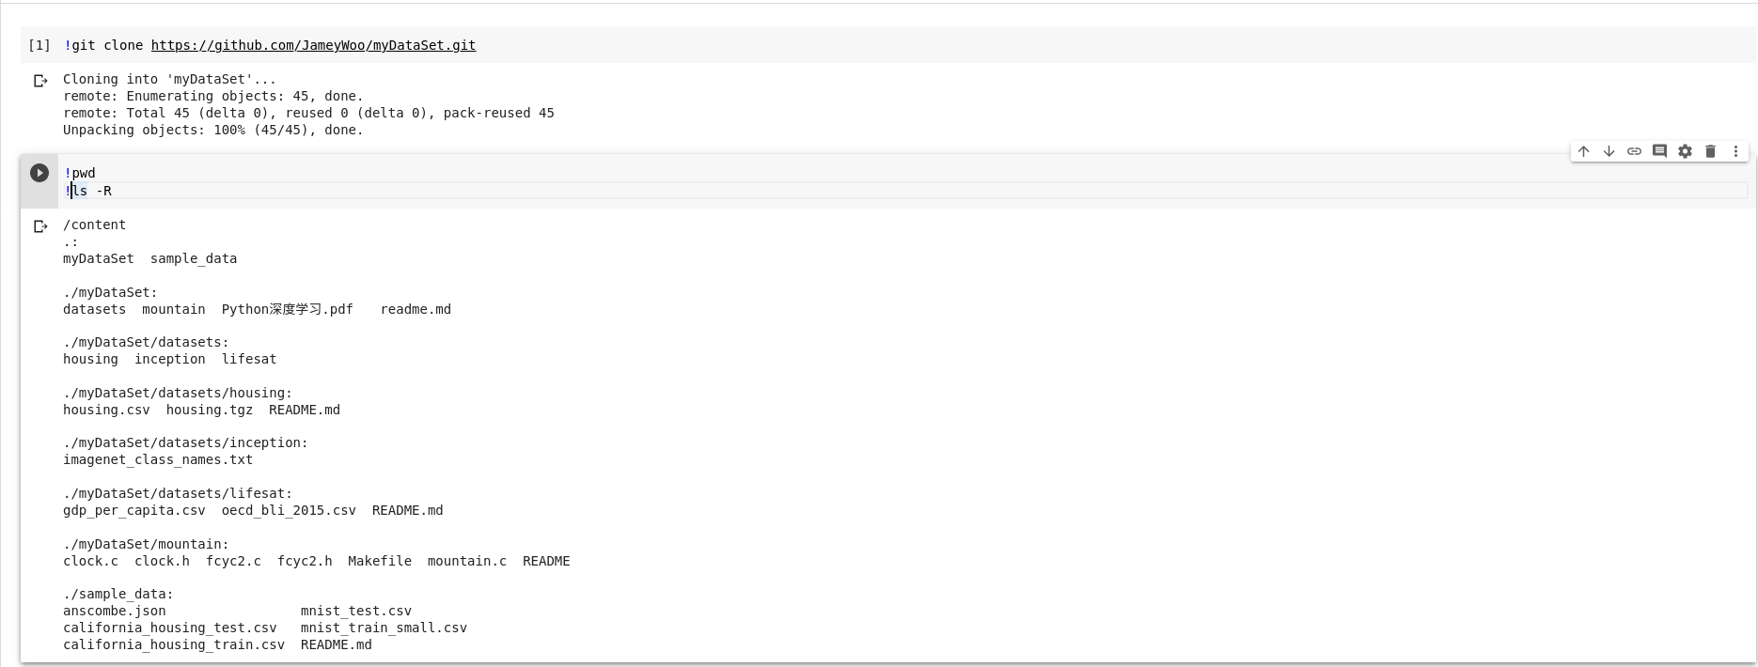

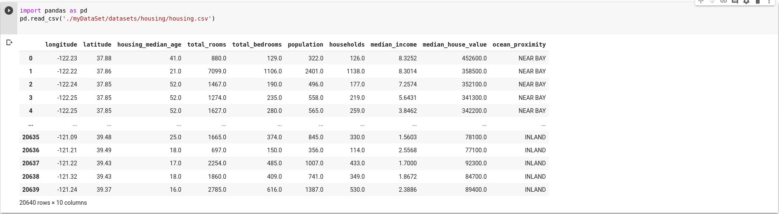

4.2) only download data file

!wget https://raw.githubusercontent.com/JameyWoo/myDataSet/tree/master/datasets/housing/housing.csv

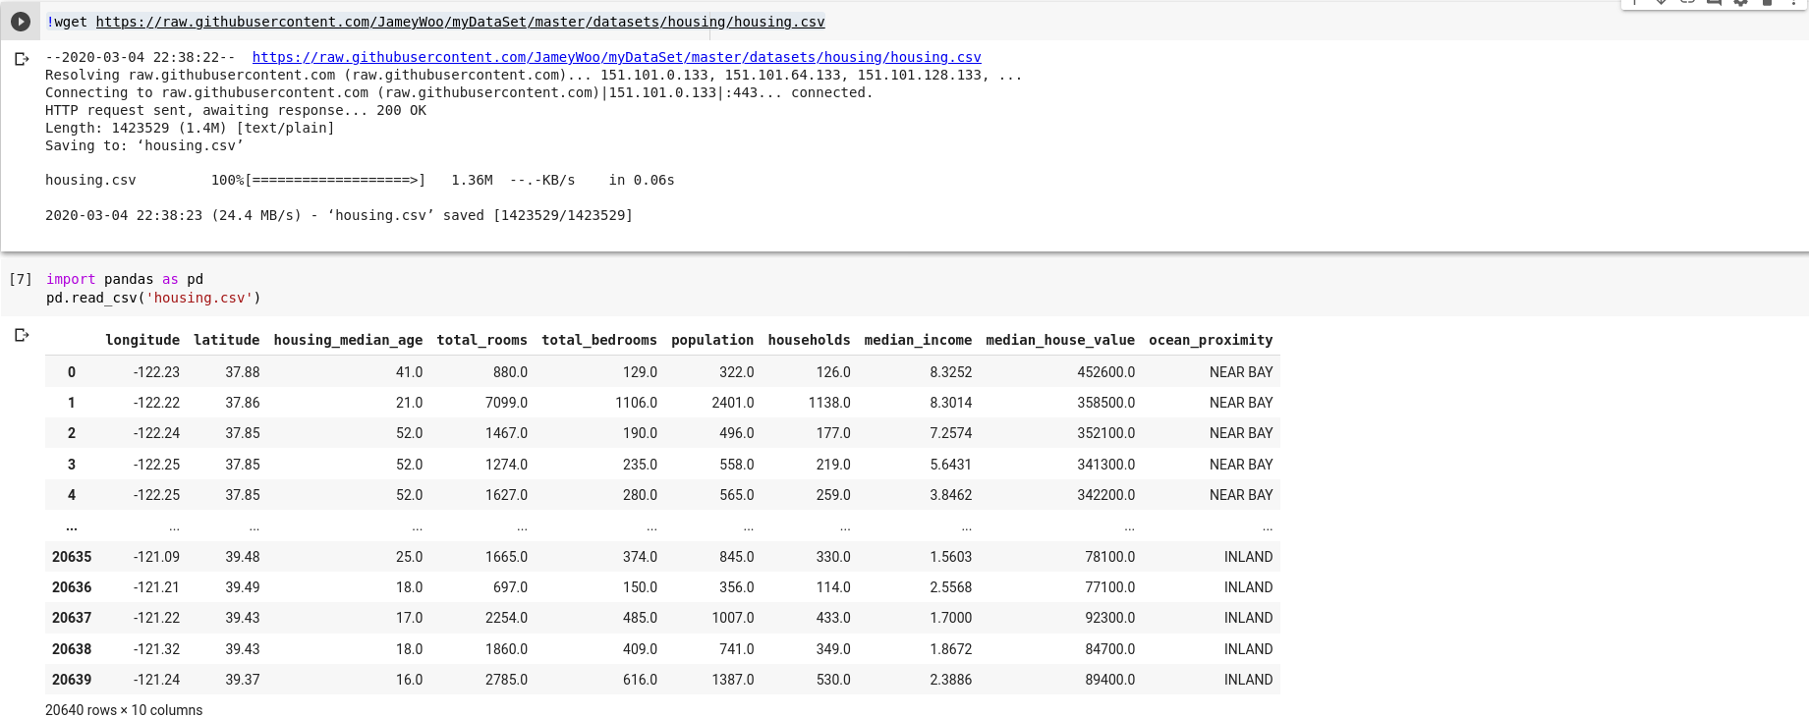

4.3) load data from drive, click the link and input the authorization code

From google.colab import drive

drive.mount('/content/drive')

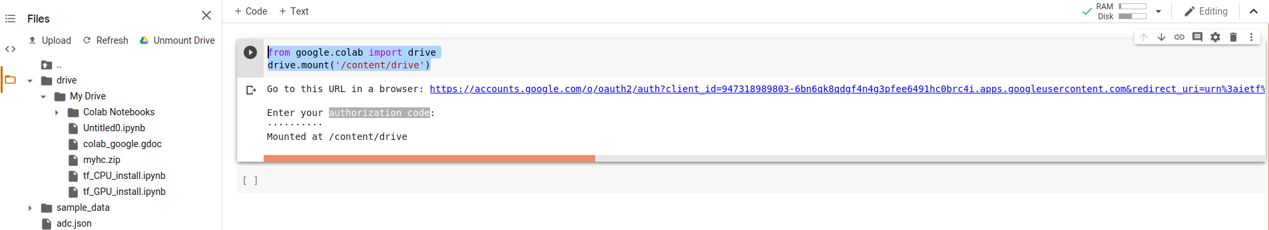

1. Download code to the local

